R.18

ENERGY DIAGNOSTICS OF TECHNICAL SYSTEMS
(Dobry Marian Witalis)

  - Introduction

Theoretical basics of energy diagnostics developed in years 1995-1998 indicate the development in the range of detailed and holistic technical systems diagnosing. Energy diagnostics of technical systems is based on a detected, accurate relationship of the mechanical systems dynamics with a power distribution and an energy flow in their structure [11, 12, 13, 14, and 15]. By using methods of system’s theory and developing a correct dynamic structure of the examined technical systems’ dynamic model, is possible to trace changes in the power distribution of working forces in the system and of the energy flow. An energy analysis of a technically efficient mechanical system provides us with the data for input values, indispensable for a state’s estimation and working diagnose out during its exploitation.

  - Energy diagnostics of technical systems at all stages of life.

Energy diagnostics can be applied to all stages of technical system’s life. Its results should be used for constructing or renovating technical systems in order to adjust them better to mental – psychical man’s characteristics and an environment protection. A lack of feedbacks, shown by colourful lines, causes a stagnation in objects and technical systems development which is followed by a detriment to the man and an environment. A lack of technical advance, caused by not making full use of the technical system diagnostics, increases real costs of enterprises, thus it decreases their income.

Table 1. En expansion with a designing feedback of technical diagnostics objectives at all stages of life of technical objects [41]
Stage of object and technical system’s life |  |  |  | A type of an energy diagnostics with taking into consideration a man and an environment. | Methods and means for energy diagnostics aiding – results of the diagnostics
1.  Designing  Constructional guidelines in diagnostics |  |  |  | Constructional energy diagnostics – an estimation of alternative constructional designs, a hierarchy of structure loads and a prevention of their concentration, an estimation of their influence on a man and an environment. | Virtual energy diagnostic models, simulation of structure’s evolution and its physical changes during object and  technical system’s life in the domain of power distribution and energy flow.
 | 2.  Production |  |  | Control energy diagnostics of the quality of production processes and the stage of receiving its products | Energy methods of the control diagnostics in all production’s stages and a final receive of its products
 |  | 3.  Exploitation |  | Exploitation energy diagnostics | Energy stationery and on-board diagnostic systems.
 |  |  | 4.  Utilization | Utilization energy methods allow taking a decision object’s utilization and its type in the whole recycling cycle. | Generalized energy methods for a complex evaluation of an exploited mechanical object, taking into consideration a presence of a man and en environment. do

The energy diagnostics enables an energy optimization which increases an energy efficiency of exploited technical objects. Moreover it increases a durability and an operational reliability of machines and devices. An energy optimal technical system impacts minimally also a man and an environment.

  - Theoretical basics of an energy diagnostics

The basis of an energy diagnostics is a relationship between dynamics of technical system and power distribution or energy flow in its dynamic structure. For energy diagnostics there are two rules created: First Rule of Energy Flow in Mechanical System and The First Rule of Power Distribution in Mechanical System. Those rules allows solving the basic problem in energy diagnostics that is the problem of determining velocity and quantity of energy flow in mechanical – biological structure and globally, on the basis of knowing movement parameters of examined structure and dynamic model of an examined technical object.
Developed method of energy diagnostics primarily requires correct modeling of dynamics of an examined technical object with taking into consideration its real structure which means structurally compatible with a real object. Results of the proceeded dynamic analysis are consecutively used for the analysis of power distribution and energy flow in the dynamic structure of an examined object. This transition form the domain of amplitude analysis to the domain of power distribution and energy flow is possible because of those two rules mentioned above.

Sformułowane zasady energetyczne
In order to obtain a theoretical description of the energy flow in mechanical and mechanical – biological systems The First Rule of Thermodynamics was used. This rule makes possible balancing en internal energy flowing in and flowing out of the system with an external energy flow. Analysed system should be the closed one or flow one with the control of all inputs and outputs.
The First Rule of Energy Flow in Mechanical System can be defined as follows:

The increase of net input energy in the system with taking into consideration loses of energy equals the sum of increases of energy (accumulated, collected) in the system and an increase of output energy of the system.

The formula is as follows:
ΔEin − ΔElos = ΔEacc + ΔEout (18.1)
Where:

$${\text{ΔE}}_{\text{in}}=L_{\text{in f}}=\int_{A}^{B}{\overset{}{{\vec{W}}_{\text{in}}}⋅d\vec{s}}$$ |  | - increase of the input energy – equals to work of external forces impacting mechanical system at the input
$${\text{ΔE}}_{\text{str}}={\text{ΔE}}_{\text{str wew}}{\text{+L}}_{\text{s op}}={\text{ΔE}}_{\text{in lo}}+\int_{A}^{B}{\overset{}{\vec{R}}⋅d\vec{s}}$$ |  | - increase of loses energy – equal to the sum of increases of internal loses in the system and work of force of resistance to movement
${\text{ΔE}}_{\text{od}}=Δ(T+U)=\int_{A}^{B}{[\vec{B}(t)+\vec{S}(t)]⋅d\vec{s}}$ |  |  | - increase of accumulated or collected energy – equals to increase of internal energy, which was called as a reflected energy in the system
${\text{ΔE}}_{\text{wy}}=L_{\text{wy}}=\int_{A}^{B}{\vec{O}⋅d\vec{s}}$ | - increase of output energy – equals to the work of external forces at the output from the system

The First Rule of Energy Flow in Mechanical System can be presented graphically in time “t” as shown at the picture 18.1.

Draw.18.1 Graphical interpretation of The First Rule of Flow of Energy and an universal model of flow of energy in a mechanical system, its subsystems, elements and reduction points.

The second of energy rules concerning Power distribution in (bio) mechanical system can be obtained by two – sided differentiation by time of the formula of TFRoEFiMS. In result an equation of power will be formulated.

$P_{\text{we}}(t)−P_{\text{str}}(t)=P_{\text{od}}(t)+P_{\text{wy}}(t);$ (18.2)

Where:

- power of resultant driving force at the input to the system – input power
- power of loses equal to the sum of powers of internal loses in the system and the power of resisting force of system movement
- reflected power (accumulated or gathered) in the mechanical system equal to the sum of inertia powers and elasticity powers
- the output power equal to the sum of output powers fro the system

Presented mathematically the rule of power distribution can be defined as:

Net input power to the system (after subtracting a power of loses) equals a reflected power in the system and output power from the system

Graphical interpretation of The First Rule of Power Distribution is show at draw.18.2.
Rys.18.2 Graphical interpretation of The First Rule of Power Distribution and a universal model of flow of energy in a mechanical system, its subsystems, elements and reduction points.

Levels of dynamic analysis in time domain

The systematics of levels of dynamic technical systems dynamic analysis used so far along with levels of new energy analysis is show in the table 2.

Table 2. Levels of dynamic analysis of mechanical and biomechanical systems in time domain. [22, 38, 40]

Nr | LEVEL OF DYNAMIC ANALYSIS  (PCHYSICAL VALUE) | NAME OF LEVEL | RULE OR RIGHT APPLIED TO  THEORETICAL DESCRIPTION,  Author of rule or right
1 | FIRST –GENERALIZED LEVEL OF ENERGY FLOW  (ENERGY DOSE IN [J]) | DYNAMIC ENERGY FLOW IN MECHANICAL SYSTEM STRUCTURE FROM SOURCES THROUGH STRUCTURE TO RECPTION OR LOSES POINTS IN SYSTEM | FIRST RULE OF ENERGY FLOW IN MECHANICAL SYSTEM  ------------------------------------  MARIAN W. DOBRY, 17.02.1996
2 | SECOND LEVEL – POWER DISTRIBUTION  (MOC W [W]) | POWER DISTRIBUTION IN DYNAMIC STRUCTER OF MECHANICAL SYSTEM | FIRST RULE OF POWER DISTRIBUTION IN MECHANICAL SYSTEM  ------------------------------------  MARIAN W. DOBRY, 17.02.1996
3 | THIRD LEVEL – WORKING FORCES  (FORCES IN [N]) | ANALYSIS OF FORCES WITH TAKING INTO CONSIDERATION MOVEMENT OF MECHANICAL SYSTEM | RULES OR RIGHTS OF MECHANICS E.G.:  ------------------------------------  NEWTON’S RIGHT,  D'ALEMBERT’S RULE  LAGRANGE’S FORMULAS OF II TYPE  GENERAL FORMULA OF DYNAMICS, ETC.
4 | FOURTH LEVEL –  (AMPLITUDES: ACCELERATIO [m/s²], VELOCITY [m/s] I DISLOCAION [m]} | ANALYSIS OF PCHYSICAL KINEMATIC QUANTITIES: ACCELERATIONS, VOLOCITIES AND  DISLOCATIONS | MATHEMATICAL METHODS OF DIFFERENTIAL SOLUTIONS OF EQUATIONS OF MOVEMENT (NORMAL OR PARTIAL)  DIGITAL SIMULATIONS WITH DIGITAL INTEGRATION IN CASE OF NONLINEAR EQUATIONS
5 | FIFTH LEVEL –  DYNAMIC STRESS IN ELEMENTS OF SYSTEM  (STRESS [Pa]) | ANALYSIS OF DYNAMIC STRESS IN ELEMENTS OF MECHANICAL | METHODS OF STRENGTH OF MATERIALS AND DYNAMICS OF MACHINES E.G.:  HUBER’S HIPOTHESIS, FATIGUE STRENGTH

It implies that currently used dynamic analysis is realized at third level of analysis. Its goal is creating differentia movement equations with consideration of all forces and with using known rights and rules of mechanics. Fourth level is an analysis of kinematical quantities obtained by solving a mathematical model of an examined system. Subsequently obtained dynamic amplitudes of dislocations enable carrying out an analysis of stresses of known variation in time which stands the basis for determining the strength and durability of the construction.
An analysis in time domain which is an instantaneous energy flow stands to be a first level.
It includes energy flow in the dynamic structure of systems from its sources to reception points or loses points in the structure of systems. A theoretical basis is stood by FRoEFiMS. It accumulates all physical values that were analyzed separately up to now, which enables a reduction of parameters and generalizing the analysis. Second level is obtained by double – sided differentiation by time FRoEFiMS. It is a level of dynamic analysis of mechanical or biomechanical system in domain of instantaneous value of distributed power to a dynamic power of systems. The rule responsible for a power distribution in the system is TFRoPDiMS. It is a level of flow analysis in time of energy flow and it determines the velocity of energy flow. It enables indicating points of the highest energy load and making a hierarchy of energy load of all elements of the system

Diagnostic energy model of dynamic mechanical structures

Energy diagnostics of technical systems as mechanical ones or biomechatronic ones requires a correct physical model. The process of modeling should be carried out very precisely with taking into consideration an energy criterion of probability between real object and physical model. Particular stages of energy modeling are shown in table 3.
Physical model of examined system, shown in the table 3, was presented after applying Elementary Processors of Energy Flow that enable transition from conventional dynamic analysis carried out in domain of amplitudes of kinetic quantities, to energy analysis in domain of energy flow and power distribution.

18.4 Criteria Quantity of energy diagnostics of mechanical and biomechatronic technical systems.

In the consequence of procedure shown in the table 3, simulation structural model, global power distribution and energy flow in examined system, is obtained. It enables monitoring instantaneous energy flow in whole dynamic structure and estimation of global changes of flow in the whole system in the consequence of: changes of technical state change of work conditions and control of an examined system. Big sensitivity of changes of energy flow in the structure and its cumulated characteristics have made possible indicating an increase of input energy and its structural flow in the system as physical criterion quantity of energy diagnostics.

Table 3. Stages of energy modeling of mechanical systems by using First Rule of Energy Flow and First Rule of Power Distribution in mechanical system.

STAGES OF ENERGY MODELING OF MECHANICAL AND BIOMECHATRONICAL SYSTEMS
FIRST STAGE | SECOND STAGE | THIRD STAGE
REAL OBJECT:  SYSTEM ANLYSIS | ENERGY MODEL OF DYNAMIC STRUCTURE OF SYSTEM | SIMULATION MODEL OF ENERGY FLOW AND POWER DISTRIBUTION OF SYSTEM STRUCTURE
ANALYSIS OF STRUCTURE, KINEMATICS, DYNAMICS, MATERIALS | ANALYSIS OF STRUCTURE DYNAMICS:  Number of degrees of freedom, compression ratios of all types, energy sources, receivers, dynamic characteristics | ENERGY SYNTHESIS OF REDUCTION POINTS, ELEMENTS OF SUBSYSTEMS AND METASYSTEMS – ANALYSIS OF STRUCTURAL AND GLOBAL ENERGY FLOW

CORRECTION CHECKUP

APLICCATIONS:  DISREGRADING PHYSICAL PHENOMENA OF SMALL INFLUENCE ON MEDLING OBJECTIVE | ENERGY CRITERION OF PROBABILITY:  ENERGY BALANCE:  E_{O} ≡ E_{M} | DYNAMICS OF MECHANICAL STRUCTURE OR BIOLOGICAL SYSTEM: PHYSICAL AND MATHEMATICAL MODEL | ELEMENTARY PROCESSOR  OF ENERGY FLOW  MWD EPPE | SIMULATION OF ENERGY FLOW IN MECHANICAL AND BIOLOGICAL SYSTEM

EXPERIMENTAL COMPARISON OF DOSES OF FLOWING ENERGY

This way, a reduction of diagnostic parameters to one basic scalar, which is a dose of energy flowing through a control point in determined time of mechanical system exploitation, was obtained. It makes possible mono - parameter evaluation of changes of technical state in real time “t” in technical or anthropotechnial system.
An increase of input energy is:
ΔE_{input} = function {[dynamics of foundation, displacement construction]; [dynamic structure of technical system and its spacial configuration]; [dynamic structure of human factor]; [identified values, parameters changeable in time of whole structure of examined metasystem]; identified sources of internal land external energies, their powers and forces, which can be released to drive, control and braking of system in work time]; [way of control of system work by a man – operator and control of mechatronic subsystems]; [real time “t” of system work]; [conditions of environment and their interactions] and other not mentioned factors.]}.
A record mentioned above indicates on dependence of increase of energy flow on full, global state of examined technical system This characteristic of increase of energy flow enables globalization of symptoms and their reduction to only one – energy symptom.

Energy symptoms of new energy diagnostics of technical systems.
As symptoms of energy diagnostics two quantities were suggested:
- A dose of input energy to the system - globally – in Jules or at all levels of structural analysis, that means: metasystem or system, subsystem, element of reduction point defined by simulation or experimentally in defined time Δt = (t₂ - t₁). It can be any time, e.g. time of system work in its one work cycle.
- Input power (in Watts) directed to the system globally or at all levels of structural analysis, which means: metasystem or system, subsystem, element of reduction point defined by simulation or experimentally in defined time “t”. It can also be any time, e.g. time of system work in its one work cycle.
- Input power presents speed of energy “to” or “from” the systems and as an instantaneous quantity enables fast energy estimation of phenomena proceeding in an examined system. As measures of signal power can be used instantaneous maximum value, average value calculated for the dose of energy or RMS in order to compare with results of experimental research.

Energy criterion for the estimation of mechanical and biomechatronic systems.

Using boundary values of energy symptoms, established theoretically for designed objects on the basis of simulation of power distribution and energy flow in the system, was proposed as energy symptoms. Valuable data for the energy diagnostics is also exploitation data about existing failures.

18.5 Examples of energy diagnostics of technical systems

1. Constructional diagnostics realized on the basis of power distribution and energy flow in the system Human – Mechanized Hand Operated Tool – Foundation.
As an example illustrating results of constructional energy diagnostics is shown energy flow in the biomechanical system – Mechanized Hand Operated Tool – Foundation. Pneumatic hammer was the examined tool.
Knowledge of propagation of energy in the diagnosed system, from its sources to significant subsystems enables an estimation of energy state of their load, which means making a diagnosis.

Draw.18.3 Pneumatic hammer |  | Rys.18.4 Energy flow in the biomechanical system – Mechanized Hand Operated Tool – Foundation for vibration safe pneumatic hammer with energy isolation system in time of one work cycle T=33ms.

2. The concentration of energy flow in biomechatronic system and diagnostic potential of energy diagnostics.

Energy diagnostics of biological – mechanical systems realized at the stage of constructing enables an estimation of efficiency of energy flow reduction and its concentration. At the drawing 18.5 is shown an average power distribution in points of reduction of dynamic model of examined full dynamic structure of Mechanized Hand Operated Tool – Foundation system for two pneumatic hammers: conventional one without vibroisolation of hand grips and one with a vibroisolation of hand grips. Energy constructional diagnostics was carried out at two system involving usage of two different hummers. Comparison of those two variants demonstrated an obvious influence of vibroisolation on average power distribution that cannot be disregarded. It should be mentioned that both tools have the same pneumatic engine.

Draw.18.5 Average power distribution in case of two different hammers usage.

3. Global diagnosis in energy diagnostics.

Energy diagnostics enables making a global diagnosis. On the basis of it, it can be stated for example: what kind of danger stands the mechanized tool for a man, for how long the technical object can be exploited during its work cycle. A global diagnosis can be made on the basis of knowledge of average power directed to all reduction points of the system. It enables calculating dose of energy, which flows form energy sources to the examined system. In case of described example of biological – mechanical system it is vital to estimate the safety of man – operator when using hand mechanized tools on the basis of the energy dose directed form the tool to the man. At the drawing 18.6 it is show a comparison between doses of energy in kJ flowing to a man – operator from different types of hammers with a boundary energy value set to 2,928 kJ for 8h of work cycle. Those hammers were: conventional pneumatic hammer MS13A without a vibroisolation, a research model of hammer MS13A with vibroisolation WoSSO, productive prototype of pneumatic hammer PM with a vibroisolation WoSSO and modernized productive prototype of pneumatic hammer MPM with a vibroisolation WoSSO after energy optimization and weight reduction. Presented results of energy diagnostics confirm the big diversification of energy doses flowing from to the man depending on the type of tool.

Rys.18.6 Comparison of input energy doses to the subsystem Man – Operator to Mechanized Hand Tools.

In case of conventional pneumatic hammer MS13A the energy dose for 8h of worki s 1405 kJ. Permissible time of exposition to vibrations caused by this tool can be calculated on the basis of energy dose by using an equation:
$t_{\text{dop} \text{eksp}\text{.}}=\frac{{\text{DE}}_{\text{8h}}}{{\text{DE}}_{\text{dop} \text{8h}}}=\frac{\text{2,928}}{\text{1405}}⋅8⋅\text{3600} =\text{60} [s]$; (18.3)
Time where: DE_{8h} – energy dose directed to the man in time of 8 h, DE_{dop. 8h} – permissible energy dose for local vibrations in time of duration for 8 h

An obtained result 60s is a permissible time of exposition to the hazard, which means that this tool is dangerous for man’s heath and shouldn’t be used. Global diagnose for experimental model MS13A+WoSSO indicates that a permissible time in this case is:
$t_{\text{dop} \text{eksp}\text{.}}=\frac{{\text{DE}}_{\text{8h}}}{{\text{DE}}_{\text{dop} \text{8h}}}=\frac{\text{2,928}}{\text{2,735}}⋅8⋅\text{3600} =\text{8,56} [h]$. (18.4)

In this case this hammer can be used for 8, 56 h. Thus, the global diagnose confirms its safety of usage for a man – operator. The global diagnosis for two other hammers also confirms their full safety of usage for a man. It can be said that the global diagnosis unequivocally allows classifying examined objects in two categories: safe or dangerous, and determining the maximum time of work for the subsystem.

18.6 New methods of visualization of power distribution phenomenon - energy portraits as tools of energy diagnostics.

Instantaneous course of power value directed to each reduction point can be presented at the power plane as an energy portrait. According to the described theory of power distribution in mechanical systems, instantaneous power directed to every reduction point contains of three types of power. Taking into consideration a phase Shift and The First Rule of Power Distribution in Mechanical System, a visualization of this rule by energy portraits was proposed at all levels of structural classification of the biological – mechanical system. Energy portrait is determined at eh power plane by the end of radius, which starts at the point of coordinates (0,0) , which axial projections are following powers: X-axis – reflected power, Y-axis – lost power.
At drawing 18 are show energy portraits for all reduction points of biological subsystem, which means man – operator, who is Anders influence of conventional pneumatic hammer MS13A without a vibroisolation. Energy portraits show energy picture of movement stabilizing of examined biomechatronic system. Steady motion at the power plane is presented by concentrated energy trajectories. Single lines visible on portraits show maximum values of power in its transition process and considerably exceed the area of steady motion. Energy portraits in each of reduction points are very distinctive. They are a very characteristic presentation of energy phenomena being carried out in the determined point of human body caused by working mechanized hand tool.

 |  | Reduction point: Body frame-Hand (direction z)
 |  | Lost Power Nstr(t) [W] | 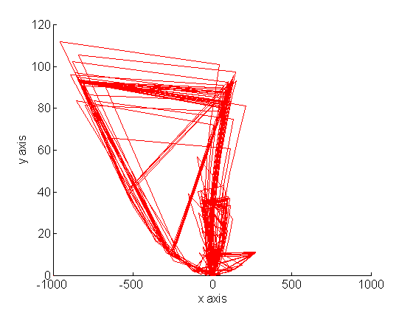  Reflected power Nod(t) [W]
 |  | Reduction Point : Forearm-Elbow (direction Z)
 |  | 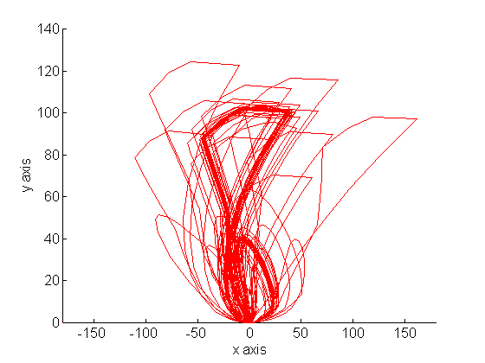  Lost Power Nstr(t) [W] | Reflected Power Nod(t) [W]
 |  | Reduction point: Arm-Shoulder (direction Z)
 |  | 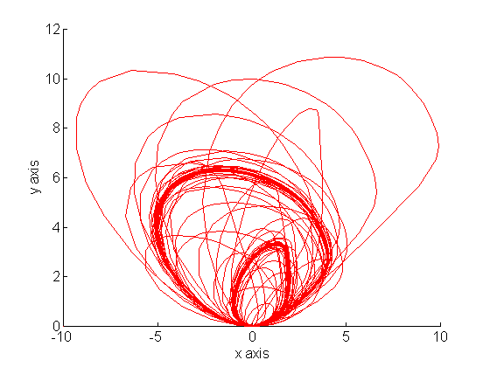  Lost Power Nstr(t) [W] | Reflected Power Nod(t) [W]
 |  | Draw.18.7 Energy portraits of energy reduction points of biomechatronic dynamic system Man – Technical object as results of power distribution simulation.

VISUALISATION OF THE FIRST RULE OF POWER DISTRIBUTION IN THE SPACE OF STRUCTURAL POWERS:

LOST POWER – REFLECTED POWER

Biological – Mechanical System:

Man – Technical Object (Mechanized Hand Tool-
Pneumatic Hammer MS13A)
M = 4,855 kg; f_{r} = 30 Hz, t_{sym} = 33 s

GLOBAL DISTRIBUTION OF TYPES OF POWER

IN ALL SYSTEM Man – Mechanized Hand Tool

WITH TAKING INTO CONSIDERATION TRANSITION PROCESS

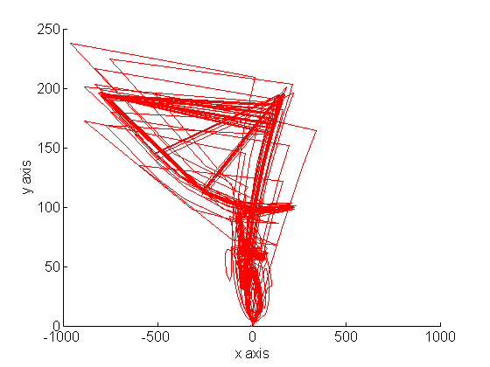  Lost Power Nstr(t) [W] | Reflected Power Nod(t) [W]
Draw.18.8 Global energy portrait of biological – mechanical dynamic system Man – Technical object (Mechanized Hand Tool – conventional pneumatic hammer MS13A without any vibroisolation) as the result of power distribution.

In the energy diagnostics of technical objects, particularly in comparison analyses, global energy portrait shown at the drawing 8 is very useful. It is obtained by making a synchronized sum of all reflected and lost powers for the whole examined system. It enables making the global diagnosis of impact of tool on the man with taking into consideration types of power or energies.

18.7 Energy diagnostics in frequency domain – amplitude – frequency characteristics of instantaneous power in the examined system.

It is vital from the standpoint of energy load of examined dynamic structure of mechanical or biological system to ask about the ranges of frequency in which the energy flow reaches maximum values. Energy diagnostics gives an answer to this question. An example illustrating those futures of energy diagnostics is the diagnosis of different powers distribution in the frequency function and theirs synchronous sum in reduction points. The examined object was the biomechatronic system Man – Percussive - Rotational Mechanized Hand Tool (percussive driller.

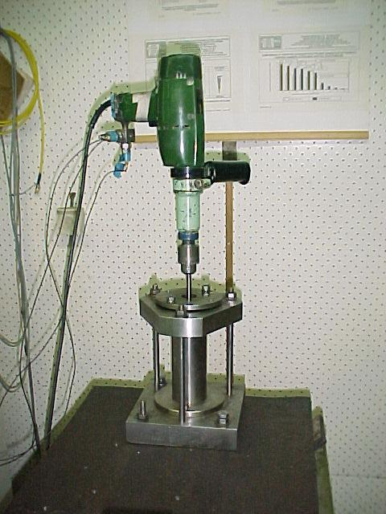

Draw.18.9 Percussive driller |  | Draw.18.10 An example of man’s position while working with a driller [42, 43]

Energy diagnostics enables making a deeper diagnosis concerning the state of danger to the man from for example using not vibroisolated drillers

Draw.18.11 Spacial physical model of biological – mechanical system

Mathematical model of examined system was created by using Lagrange’s equations of second type:

$(m_{\text{1zN}}+m_{\text{1zR}}+m_{\text{1zL}}) {\overset{¨}{z}}_{1}+(c_{\text{1zR}}+c_{\text{1zL}}) {\overset{˙}{z}}_{1}+(k_{\text{1zR}}+k_{\text{1zL}})z_{1}−c_{\text{1zR}} {\overset{˙}{z}}_{\text{2R}}−k_{\text{1zR}}z_{\text{2R}}=F_{z}(t) ;$
$m_{\text{2zR}}{\overset{¨}{z}}_{\text{2R}}+(c_{\text{1zR}}+c_{\text{2zR}}) {\overset{˙}{z}}_{\text{2R}}+(k_{\text{1zR}}+k_{\text{2zR}})z_{\text{2R}}−c_{\text{1zR}} {\overset{˙}{z}}_{1}−k_{\text{1zR}}z_{1}−c_{\text{2zR}} {\overset{˙}{z}}_{\text{3R}}−k_{\text{2zR}}z_{\text{3R}}=0 ;$(18.5)
(18.6)
$m_{\text{3zR}} {\overset{¨}{z}}_{\text{3R}}+(c_{\text{2zR}}+c_{\text{3zR}}) {\overset{˙}{z}}_{\text{3R}}+(k_{\text{2zR}}+k_{\text{3zR}})z_{\text{3R}}−c_{\text{2zR}} {\overset{˙}{z}}_{\text{2R}}−k_{\text{2zR}}z_{\text{2R}}=0 ;$
(18.7)
$J_{z} {\overset{¨}{ϕ}}_{z}+(c_{\text{1yL}} b^{2}+c_{\text{1xR}} a^{2}) {\overset{˙}{ϕ}}_{z}+(k_{\text{1yR}}b^{2}+k_{\text{1xR}} a^{2})ϕ_{z} =M_{z}(t)$
(18.8)
where:
(18.9)

- Collision forces generated by the working driller on its body frame
- S impulses of collision forces,
- δ_{T} T- periodic Dirac’s delta,
$M_{z}(t)=R μ F_{z}(t)+M_{\text{oz}}(t)$
(18.10)
- Impulse rotational torques connected with collision force in z direction and an additional anti – torque connected with resistance to motion during percussive drilling,
- R radius of working tool,
- μ friction factor

.

Characteristic of power of inertia  Ch.M.b.(f) [W] | Characteristic of power of loses  Ch.M.str.(f) [W] | Characteristic of power of elasticity  Ch.M.spr.(f) [W] | Characteristic of power in the reduction point  Ch.M.C.p.r.(f) [W]
Punkt redukcji: Korpus wiertarki-Dłonie (kierunek Z)
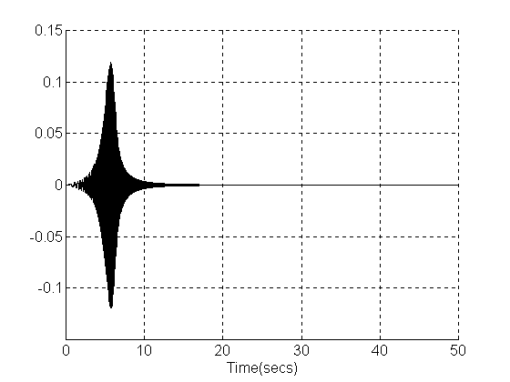  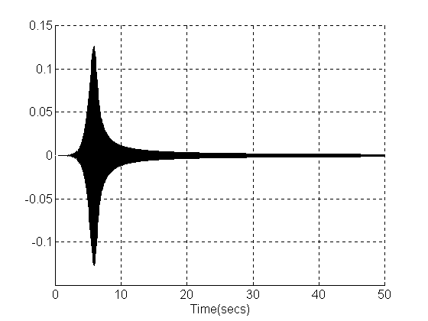  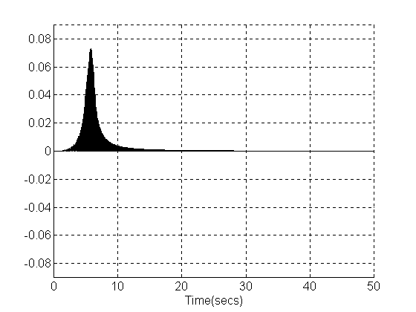  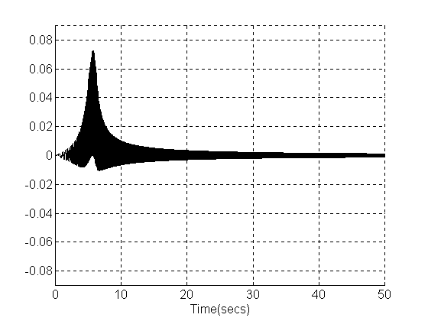  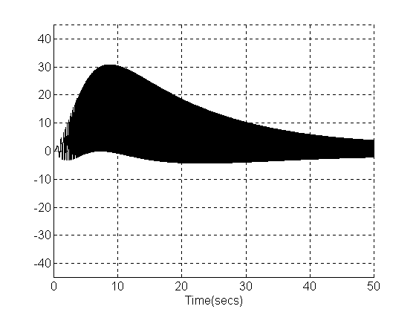  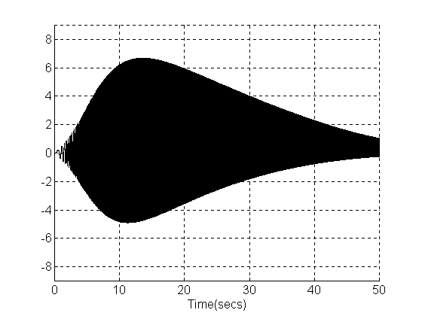  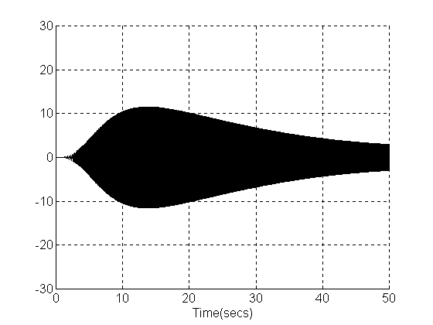  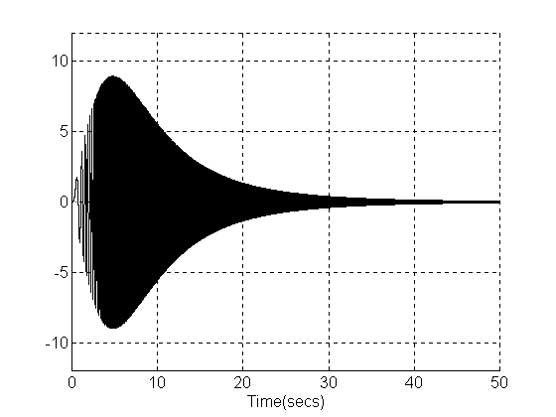  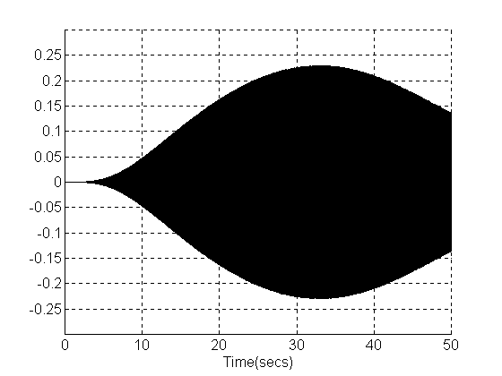  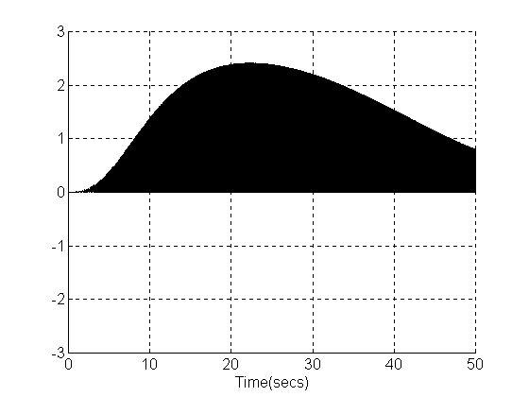  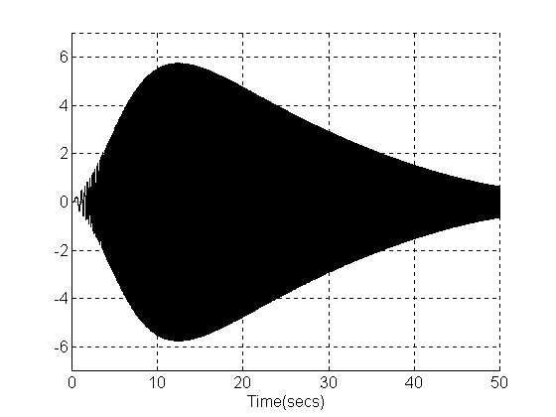  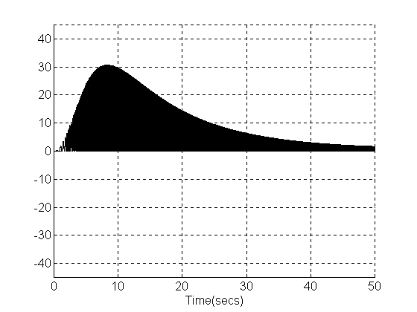  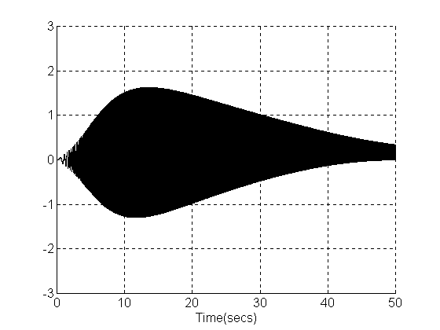  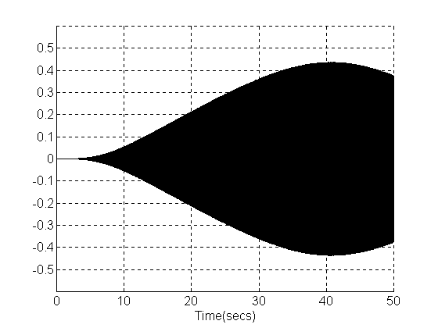  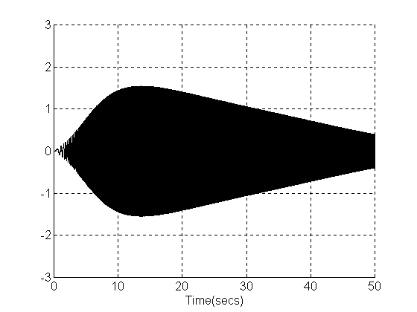  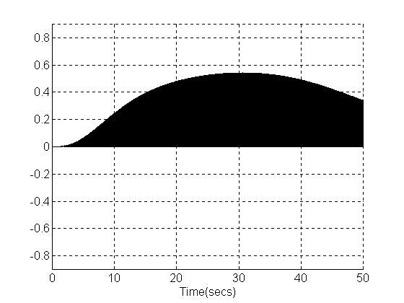  Frequency Hz | Frequency Hz | Frequency Hz | Frequency Hz
Punkt redukcji: Przedramię-Łokieć (kierunek Z)
Frequency Hz | Frequency Hz | Frequency Hz | Frequency Hz
Punkt redukcji: Ramię-Bark (kierunek Z)
Frequency Hz | Frequency Hz | Frequency Hz | Frequency Hz
Punkt redukcji: Korpus wiertarki (obroty wokół osi Z – kierunek ϕ)
Frequency Hz | Frequency Hz | Frequency Hz | Frequency Hz
Draw.18.12 Characteristics of structural power distribution for all reduction points in the frequency band from 0 to 50 Hz for biomechatronic system Man – Percussive Rotational Mechanized Hand Tool

The analysis of energy characteristics of different sorts of power indicates the following regularity: maximum values of power occur in the same order on the frequency axis for all reduction points. The lowest frequency has the power of elasticity, then the power of loses and then the power of inertia.

Global characteristic of reflected power in the system | Global characteristic of power of loses in the system | Global characteristic of input power in the system
Moc odbita N_{odb} (f)  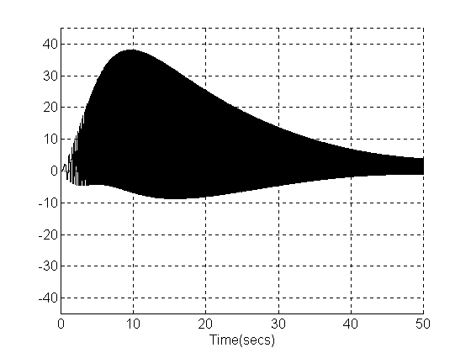  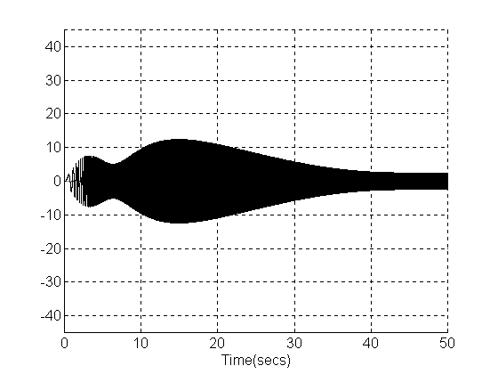  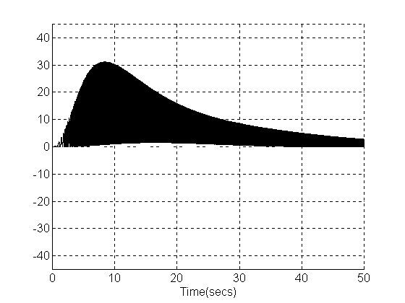  Frequency Hz | Moc strat N_{str}(f)  Frequency Hz | Moc wejściowa N_{we}(f)  Frequency Hz
Draw.18.13 Global characteristic of components of The First Rule of Power Distribution in Mechanical Systems in the frequency domain in the frequency band of 0-50 Hz for the system Man – Precussive Rotational Mechanized Hand Tool.

18.8 The sum up

Represented above original energy diagnostics of technical systems enable a versatile, detailed and global analysis indispensable for carrying out a holistic estimation of technical condition, working out the diagnosis and prognosis. The energy diagnostics also enables constructing energy – safe mechanized hand tool for the man.

Literature

- Bovenzi M.: Epidemiological aspects of exposure-response relationship in the hand-arm vibration syndrome, Proceedings. Eighth International Conference on Hand-Arm Vibration, 9-12 June 1998, Umeå, Sweden, pp. 205-215.
- Burstrőm L., Bylund S. H.: The influence of vibration-free periods on the absorption of power, 35^{h} United Kingdom Group Meeting on Human Responses to Vibration, held at ISVR, Southampton, 13-15 September 2000, England, pp. 83-88.
- Cempel C.: Podstawy wibroakustycznej diagnostyki maszyn, WNT, Warszawa 1982.
- Cempel C.; Wibroakustyka stosowana, PWN, Warszawa, 1989.
- Cempel C.: Theory of energy transforming systems and their application in diagnostics of operating systems. App. Math. And. Comp. Sci., Vol. 3, 1993, 533-548.
- Cempel C.: Damage initiation and evolution in operating mechanical systems, Bulletin of the Polish Academy of Sciences, Technical Sciences Vol. 40, No. 3, 1992.
- Cempel C.: Energy dissipation in mechanical systems its description and control. The International Workshop on Machine Dynamics and Production Automation. Technical University of Szczecin, Mechanical Technology Institute & Institute of Production Engineering and Machine Tools University of Hannover, Germany, April 20-22, 1995.
- Cempel C., Natke H.G.: Energy Processors and Energy Transformation in System Engineering. W: Seminar materials. Systems Engineering, Summer school/Seminar, August 27-31, Poland, Poznan University of Technology, 1995, 36-67.
- Cempel C., Natke H.G.: Holistic Dynamics of Systems. J. Sys. Eng. No 6, London, Springer, 1996, 33-45.
- Cempel C., Natke H. G.: The modelling of Energy Transforming and Energy Recycling Systems. J. Syst. Eng. No 6, 1996, London, Springer, s. 79-88.
- Dobry M.W.; Energy flow in a power-unit of hand-held impact tools with vibro-isolation of feed force realised by WOSSO system. Ninth World Congress on the Theory of Machines and Mechanisms. Proceedings, Politecnico di Milano, 29 August / 2 September 1995, Italy, 2765-2769.
- Dobry M.W.: Przepływ energii w systemie: Człowiek - Ręczne Narzędzie Uderzeniowe - Podłoże (CNP) z zastosowanym subsytemem wibroizolacji WoSSO. Energy flow in Human - Tool - Base System (MTBS) with application of WoSSO vibroisolation subsystem. XVIIth Symposium Vibrations in Physical Systems, Poznań - Błażejewko, 1996, s.98-99.
- Dobry M.W.: Energy flow in Man –Tool – Base System, Lecture Notes of the ICB Seminars, Vol.29, Wyd. International Centre of Biocybernetics, Warszawa 1996, pp.35-56.
- Dobry M.W.: Energy flow in Human – Tool – Base System (HTBS) and its experimental verification, Proceedings. 1998, Umeå, Sweden, pp. 31-40 .
- Dobry M.W.: Optymalizacja przepływu energii w systemie Człowiek – Narzędzie – Podłoże (CNP)., Wyd. Politechniki Poznańskiej 1998; Seria: Rozprawy Nr 330, Poznań, 1998, 128 s.
- Dobry M.W.: Energetyczne wskaźniki bezpieczeństwa (EWB) mechanicznych i biomechanicznych systemów, Vibrations in Physical Systems, Błażejewko, 1998 s. 95-96.
- Dobry M.W.: Skuteczna ochrona człowieka przed energią drganiową. Materiały konferencyjne. Sympozjum Wpływ Wibracji na Otoczenie, 1998, Kraków-Janowice, s. 121-128.
- Dobry M.W.: Energy coefficients of safety (ECoS) of power driven hand-held tools. Proceedings. Vol. 5, Tenth World Congress on the Theory of Machine and Mechanisms, University of Oulu, June 20-24,1999, Finland, pp. 1956-1961.
- Dobry M.W.: Energy flow in the dynamic structure of a human-tool-base system and effective protection of the human subsystem against energy transmitted from hand-held impact tools. PROCEEDINGS. Copenhagen - Lyngby 5-8 July 1999, pp. 1953-1958.
- Dobry M.W.: Dystrybucja mocy w dynamicznej strukturze systemu Człowiek - Maszyna. Acta of BIOENGINEERING and BIOMECHANICS, Vol. 1, 1999, s. 105-108.
- Dobry M.W.: Energy coefficients of safety (ECoS) of power driven hand-held tools, Proceedings. Vol. 5, University of Oulu, June 20-24,1999, Finland, pp. 1956-1961.
- Dobry M.W.: Energetyczne oddziaływanie drgań technicznych środków transportu na organizm ludzki - Wprowadzenie. Materiały konferencyjne. Międzynarodowe Seminarium Naukowo-Techniczne, Politechnika Warszawska, Warszawa, 1999 s. 125-134.
- Dobry M.W.: Pierwsza Zasada Przepływu Energii jako podstawa uogólnionej metody analizy dynamicznej systemów mechanicznych; Materiały konferencyjne, Krajowa Konferencja „Napędy’99”, Szczyrk, 1999 s. 117-122.
- Dobry M.W.: Uogólniona - energetyczna metoda analizy dynamicznej struktur mechanicznych i biomechanicznych. Vol. IX, Kraków 2000, pp. 93-98.
- Dobry M.W.; Energetyczna ocena norm drganiowych. VOL. V. WAVE METHODS AND MECHANICS IN BIOMEDICAL ENGINEERING, Ed. by Polish Acoustical Society, Kraków 2000, s. 169-174.
- Dobry M.W.: Energy flow in Human-Tool-Base System (HTBS) and its experimental verification. Proceedings, Sweden, 2000 pp. 31-40.
- Dobry M.W.: Generalised theory foundations of advanced energy condition monitoring of machines, Abstracts and invited lectures, Błażejewko 2000, pp. 96-97.
- Dobry M.W.: Teoretyczne podstawy energetycznej metody oceny konstrukcji maszyn i mechanizmów. Proceedings, Warszawa- Jachranka, 2000 s. 91-96.
- Dobry M.W.: Advanced analysis of Human - Machine Systems in energy flow domain, 35^{h} United Kingdom Group Meeting on Human Responses to Vibration, Southampton, England, 2000 pp. 89-99.
- Dobry M.W.: Podstawy teoretyczne uogólnionej - energetycznej diagnostyki struktur mechanicznych i systemów biomechanicznych. II Międzynarodowy Kongres Diagnostyki Technicznej, Warszawa s. 95-105.
- Dobry M.W.: Przepływ energii w przypadkach złożonych stanów interakcji w systemie Człowiek - Maszyna. Wprowadzenie. Acta of Bioengineering and Biomechanics, Vol. 2, Wroclaw 2000, pp. 131-136 .
- Dobry M.W.: Podstawy zaawansowanej diagnostyki energetycznej systemów mechanicznych i biomechanicznych. Diagnostyka Vol. 23, Olsztyn 2000 s. 23-26.
- Dobry M.W.: Generalised theory foundations of advanced energy condition monitoring of machines, Abstracts and invited lectures, Błażejewko 2000, pp. 96-97.
- Dobry M.W.: Characteristics of structural and global power distribution in mechanical and biomechanical systems as foundation for their diagnostics, Polish Acoustical Society, Kraków 2001 pp. 17-24.
- Dobry M.W.: Analysis of structural energy flow in mechanical and biomechanical systems, Abstracts, 2001 – Nancy, France.
- Dobry M.W.: Podstawy energetycznego modelowania, analizy i diagnostyki w systemach mechatronicznych i biomechatronicznych, V Szkoła Metody Aktywne Redukcji Drgań i Hałasu, Krynica 2001.
- Dobry M.W.: Energetyczne portrety strukturalnego i globalnego rozdziału mocy w systemach mechanicznych i biomechanicznych jako podstawa ich energetycznej diagnostyki. MECHANIKA nr 83, Politechnika Krakowska, Kraków 2001 s. 57-68.
- Dobry M.W.: Energy diagnostics and assessment of dynamics of mechanical and biomechatronics systems, Machine Dynamics Problems 2001, Vol. 25, No.3/4 Warsaw University of Technology, Warsaw 2001, pp. 35-54.
- Dobry M.W.: Energy diagnostics of biomechanical systems with application of energy portraits of instantaneous power distribution characteristics, Structures – Waves – Biomedical Engineering, Structural Acoustics, 2001, Vol. XI, No.1, Kraków 2002 pp. 19-28.
- Dobry M.W.: Energy analysis of mechanical and biomechanical systems, Abstracts and invited lectures. XXth Jubilee Symposium Vibration in Physical Systems, Poznań-Błażejewko, 2002 pp. 18-33.
- Dobry M.W.: Energetyczna diagnostyka systemów biologiczno-mechanicznych, Konferencja Diagnostyka Techniczna’ 2003, Politechnika Śląska, Węgierska Górka 2003.
- Dobry M.W.: Procesy przejściowe przepływu energii w systemach biologiczno-mechanicznych Człowiek – Zmechanizowane Narzędzie Ręczne, X Konferencja Naukowa Wibrotechniki i Wibroakustyki, Kraków 2003.
- Dobry M.W.: Energy analysis of mechanical and biomechanical systems, Studia I Materiały LIII, Technika 3, Zielona Góra 2003 s. 137-158.
- Dobry M.W., Kolecka M.: Energetyczny wpływ drgań ogólnych na organizm człowieka, Zeszyty Naukowe MECHANIKA nr 83, Polit. Krakowska, Kraków 2001 s. 69-76.
- Dobry M.W., Kolecka M.: Rozdział mocy w systemie Człowiek – Pojazd, Proceedings 12th International Conference on Noise Control, 2001 Kielce, CIOP Warszawa 2001 s. 95-101.
- Dobry M.W., Miszczak M.: Dynamiczny model systemu Człowiek – Maszyna w przypadku posługiwania się dużymi narzędziami zmechanizowanymi, Acta of Bioengineering and Biomechanics, Vol. 2, Wrocław 2000 pp. 125-130.
- Engel Z.: Ochrona środowiska przed drganiami i hałasem, PWN, Warszawa, 1993.
- Griffin M. J.: Handbook of human vibration, London: Academic Press, 1990.
- Karnopp D., Rosenberg R.: System dynamics: A unified approach, A Wiley-Interscience Publ. 1975, John Wiley & Sons New York / London / Sydney / Toronto.
- Kaźmierczak H.; Analiza rozkładu mocy obciążeń dynamicznych w systemach mechanicznych, Wyd. Politechniki Poznańskiej, Rozprawy nr 363, Poznań 2001.
- Layon R.H.: Statistical Energy Analysis of Dynamical Systems: Theory and Applications, MIT Press. 1975.
- Lundström R.: Absorption of mechanical energy in the skin of human hand while exposed to vibration, J. Low Freq. Noise Vib. No 3, 1987, 113-120.
- Lindqvist B.: Power Tool Ergonomics, Boardwalk International AB, 1997.
- Markiewicz L.: Fizjologia I higiena pracy. Wibracja. Instytut Wydawniczy CRZZ, Warszawa 1980.
- Nader M.: Modelowanie i symulacja oddziaływania drgań pojazdów na organizm człowieka. Oficyna Wyd. Politechniki Warszawskiej, Warszawa 2001.
- Orłowski Z.: Diagnostyka w życiu turbin parowych. WNT, Warszawa 2001.
- Panuszka R.: Metody całkowe i energetyczne w akustyce. Wyd. PTA w Krakowie, Kraków 2000.
- Pavic G.: Acoustical power flow in structures. A Survay. Inter Noise 88, Avignion, France, 1988 pp.101-104.
- Pelmear P. L., Taylor W., Wasserman D. E.: Hand-Arm Vibration, Van Nostrand Reinhold, New York.
- Praca zbiorowa pod redakcją C. CEMPLA.; Wnioskowanie diagnostyczne, Materiały IX Szkoły Diagnostyki, Politechnika Poznańska, IMS, Poznań-Rydzyna 1989.
- Taylor W., Pelmear P. L.: Vibration White Finger in Industry, Academic Press, London – New York – San Fancisco, 1973.
- Tytyk E.: Projektowanie ergonomiczne, PWN, Warszawa-Poznań 2001.
- Wasserman D. E.: Human Aspects of Occupational Vibration, Elsevier, Amsterdam – Oxford – New York – Tokyo 1987.
- Wojsznis M.; Dobry M.: The Influence of Tool Mass on Energy Phenomena in a Biomechanical Human – Big Demolishing Hammer System, Vol. XII, No. 1, Polish Acoustical Society, Division Kraków, Kraków 2003, pp. 141-150.
- International standardisation organisation, ISO/FDIS 10068:1998. Mechanical vibration and shock – Free mechanical impedance of human hand-arm system at the driving point.

