Small towns in rural areas

Project objectives: to study German small towns (up to 7000 inhabitants) in different types of rural areas - analysis of features and problems - implementation of local action areas

1) Typical lines of development of small German towns in rural areas:?
Since 1972 (in eastern Germany since 1992) concentration of the first local government, public and private infrastructure in small towns from surrounding villages. This strengthening of rural micro-regions as center points. Since about 1990, in some cases net of public and private infrastructure, in part, massive job losses, thus increasing tendency of migration. ? Except in small towns or on the edge of compression regions, have occasionally to this day immigration from condensation nuclei on (businesses, residents - walk the edge)

2) features / characteristics of small towns

A. All these three small towns of rural centers unique? Small regions?

Small Towns in rural areas

Figure 1: Location City of Scheinfeld affiliated sites

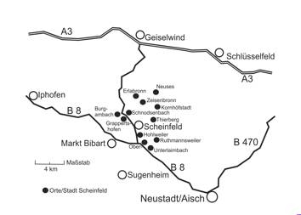

Small Towns in rural areas
B. Unique, hard to replace functions for small regions
- Residence for more of the population (50 - 70%)
- Place the vast majority of employment / jobs (60 - 80%)
Furthermore:
- Centers for purchase of daily need (retail only
related)
- Educational centers with all the associated facilities / services
- Centers for health services and care of children,
Youth and seniors
- Major cities for culture, entertainment, sport and leisure activities
- Seat of local government and other community facilities
- Supply and disposal facilities are often not focused, but
as appropriate spread over the small region.

Small Towns in rural areas
3) Investigated Fields
- Urban development: Despite declining population - identification of new
or use of existing building areas still practical urban policy.
- Inter-municipal cooperation: Encouraging approaches
Common: - business parks - Supply and disposal facilities - tourism
tourism / city marketing - regional development - for urban development
usually only if joint participation in funding
(Such as urban redevelopment east / west).
- City Marketing: a) external marketing: Almost without exception to all areas
the external representation / advertising extended. b) Internal Marketing (solutions
conditions for urban policy with / by the public): Possibilities of a total of only-
sets used, individual cases show great range / broad impact
of this subject on.
- Conservation / protection of social capital: In the Middle satisfactory / good
Funded by city policy, as a deliberate, systematic policy-expandable
Capable / - worthy.

4) Other series: implications - ensuring the functions of small
Cities and rural small regions.

