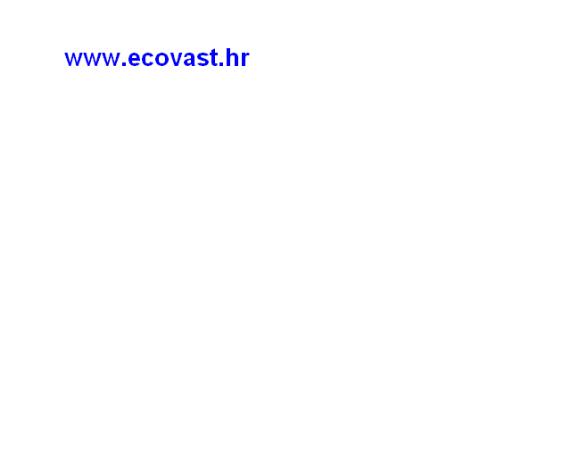
_________________________________________________________________________________________________________________
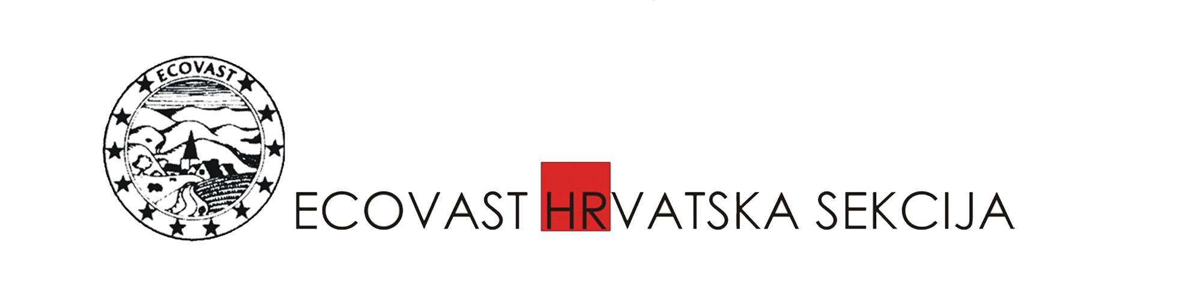
CROATIAN SECTION OF ECOVAST (EUROPEAN COUNCIL FOR THE VILLAGE AND SMALL TOWN

ECOVAST- European Council for the Village and Small Towns – established in 1984 as
• a campaigning organisation, for the well-being of the people and the heritage of rural Europe; and
• a networking organisation, which seeks to support, and to encourage cooperation between its members as they pursue their activities in rural areas.
ECOVAST has national sections in Austria, Croatia, Germany, Hungary, Macedonia, Poland, Romania, Russia, Slovakia, and the United Kingdom, and planned in other countries. These provide a focus for exchange and activity in each country, to benefit its rural communities and rural heritage.

As a campaigning organisation, ECOVAST seeks to express the concerns of its members throughout Europe to policy-makers, official bodies and others; and to make their views felt in the debates which affect the future of rural Europe.
ECOVAST has consultative status with the Council of Europe, and takes part in the regular meetings of the Council's Rural and Environmental Interest Group. We have consultative status with the European Commission, with a sit in the Commission's Advisory Committee on Rural Development.
ECOVAST has formal working relations with many other European rural and heritage organizations. There are two active groups - Landscape and Rural Architecture; they exchange experience and encourage informal contact between their members. ECOVAST organizes meetings, seminars and other public events, giving also technical expertise and advising on heritage and development issues of villages and small towns in Europe. www.ecovast.org
Croatian Section of ECOVAST (European Council for the Village and Small Town) was set up in 1993. It is active on the entire Croatian territory and links all members, professionals and interested individuals, as well as representatives of other organizations of civil society, institutions, state administration and regional and local self government units, to support homogeneous and sustainable development and to protect the heritage in rural areas, according to its published Strategy.

The Section has a number of projects elaborated in collaboration with other Croatian institutions, like Vinica Arboretum Restoration; Strategy for Rural Europe with Position Statement (Croatian translation); Heritage Trails – Both Sides of the Kupa River (interpretation panels set and brochures published); Identification and Valorization of Makarska-Biokovo Landscape (a publication).

In cooperation with ECOVAST International on ASSET project (Action to Strengthen Small European Towns) a separate project on Croatian Small Towns has been started. A number of local projects have been initiated involving heritage as tourism asset (Bednja and Trakoscan area, East Slavonia area etc.).

In 2007 the Section hosted ECOVAST General Assembly with an International Conference on Small European Towns – their Role in Rural Development and Heritage Protection, Samobor 13-17 October, with an excursion to Lika, Primorje and Gorski Kotar area (towns of Ogulin, Otočac, Senj, Delnice). On this occasion the Samobor Declaration was issued.
In 2009, the Small Towns Project continues with the 2nd International Conference Revitalization of Historical Small Towns and their Hinterland, with Pilot project: Moscenice the Living Museum Town, organized in Moscenice 23-24 October, together with the Chakavian Dialects and Culture Assembly of the Municipality Moscenicka Draga. The Moscenice Memorandum was adopted.
In 2010, the Small Towns Project further continues with the 3rd International workshop: Landscape of the Hrvatsko zagorje region: past, present condition, future, Tuheljske Toplice, October 21-22, in cooperation with Krapina-Zagorje County.

The Section collaborates with ECOVAST International and national sections, PREPARE, EUROPA NOSTRA, CIVILSCAPE, HMRR and other civil organizations, institutions, individual experts, national, regional and local governments, general public. The Section is one of seven founders of the Croatian Network for Rural Development (HMRR) www.hmrr.hr

