R.19

ENERGY ANALYSIS OF MACHINE TECHNICAL STATE
(Kaźmierczak Henryk)

19.1 Assessment of state of machine
If we want to determine condition of machine, we do not measure parameters of particular parts of machine but measurable parameters of machine function processes. Process of qualitative changes of machine is continuous. It entails the infinity of possible machine conditions. That is why all those conditions should be classified. Nonetheless, sometimes it is very difficult to make a full classification, thus, it is the best to choose a one representative of the whole class of states. Practically it is enough to determine the compatibility between signals that comply with their states. Each class should be assigned a distinctive signal, different from other signals.
The most valuable signals in terms of information contents about machine functioning are changeable signals. Lets describe the set of possibile states of machine by W and the set of signals providing us with information about the condition of machine by V. Let F to be the function assigning to each element of set W an element of set V, and opposite way. W, V is vector quantities, characterized by not one but by many number parameters. We can determine a function defining the change of state (failure) if we are given a rule describing the dependence between the set of symptoms and the set of failures, malfunctions. Let’s consider n-dimensional space with an extracted W area, so that every point complies with its defined state of machine and on the contrary.
Let two states of machine and to be considered. In order to estimate how close to each other these two states are, the distance between them should be assessed. For n-dimensional space:
$ρ\left(w^{'},w^{''}\right)=\sqrt{\sum_{i=1}^{n}{{\left(w_{i}^{'}−w_{i}^{''}\right)}^{2}}}$ (19.1)
Every class of states $W_{i}\left(i=1,2,K,r\right)$ can be assigned to the probability$P_{i}$ that the state of machine in the considered moment “t” depends on that class.
Knowing the probability, the indeterminacy of the state in the moment “t” can be estimated by using the idea of entropy:
$H\left(W\right)\text{=-}\sum_{i=1}^{n}{P_{i}\text{log}P_{i}}$ (19.2)
After confirming the existence of some characteristic $V_{j}$ probabilities of states will remain unchanged if this property does not contain the information about the state of machine, or will change but then the $H'\left(\frac{W}{V_{j}}\right)$, means indeterminacy decreases.
The symptom can be assessed on the basis of quantity of information about the machine that is provided by this symptom:
$I\left(V_{j}\right)=H\left(W\right)−H\left(\frac{W}{V_{j}}\right)$ (19.3)
Where $\left(\frac{W}{V_{j}}\right)$ – entropy of state of machine after confirming the existence of property $V_{j}$.
In the theory of reliability the description of arbitrary state of machine, particularly its failure, is considered as a random event. There is a statement used: If properties of input processes of machine are changed, it means that it is caused by the change of external conditions or the change of machine technical state.

19.2 Evaluation criteria of state of machine in regard of detrimental influence of vibrations.
The most complete evaluation criteria of machine in regard of level of mechanical vibrations are given by the standard ISO 2372.
According to this standard the only parameter of assessment of dynamic state of machine is root-mean-square value of mechanical vibrations velocity. It has been pointed out that in geometrically similar and made of the very same material parts of machine there is the same stress when velocities of vibrations are equal and on the contrary. A detailed analysis of point estimations of velocities of machine mechanical vibrations points out that the multiplied value of effective velocity determines velocities complying with maximum speed of equivalent harmonic vibrations.
(19.4)
I case of carrying out harmonic analysis:
(19.5)

The general classification of machines is described in the standard ISO 2372.

19.3 Energy characteristics of evaluation and optimization of construction.

A machine considered as an elaborate mechanical system being an assembly of subsystems: driving, working, and foundation construction, is the mechanical system of determined spacial distribution of rigidities, suppressions and masses. Dynamic properties of machine are derivative of spacial distribution of physical parameters of machine, boundary conditions and the way of its aggregation with driver source.
The technical state of mechanical objects is created in the designing process by constructional methods of constructional diagnostics and is the object of optimization at the stage of prototype improvement. The data for optimization is obtained during usage of machines.
Overloads shortening time of usage of machine have the major impact on the durability of machines or their elements. The knowledge about a spacial distribution of duties of mechanical object in the function of time of exploitation enables to identify elements put under burden.
In almost all machines bearings are considered to be the most burdened elements and their failure may lead to the catastrophe of objects where they are installed in.
The failure may occur as a result of evolutional destruction process or an instantaneous overload. The destruction of mechanical system is when the dose of energy or power causes the change of its structural properties or when boundary values are exceeded during constant accumulation of energy (power), causing the constructional node to be destructed. Those processes are one of energy type. I fan increase of external forces working is bigger than the boundary increase of internal energy, then the change of construction configuration to disordered one follows, which entails the destruction of this fragment of structure. The direct cause of destruction of material is the loss of balance stability in the misshaped material.

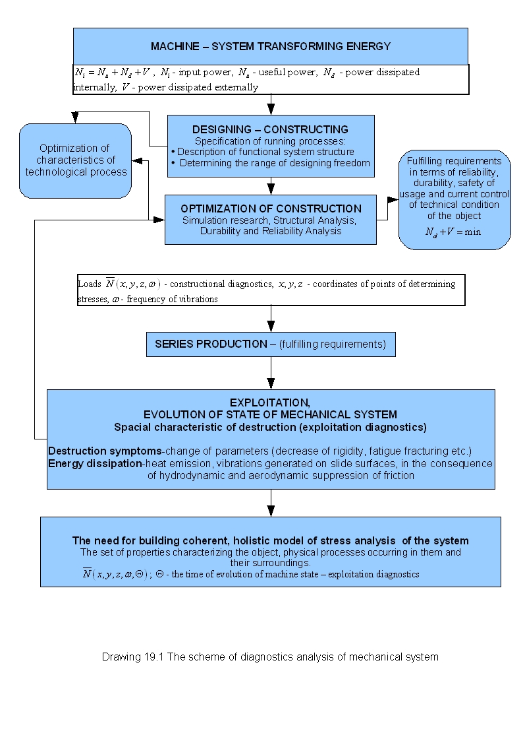

The state of machines is exposed to the evolutional destruction as a result of constructional materials wear, overloads, abrasive wear etc... Node elements of machines, (bearings), elements of driver system, working sets. The decrease of their durability may occur as a result of evolutional destruction process or instantaneous overloads. This may lead to their failure and moreover to the destruction of machine where they are installed in. Thus, there is a need of control examination of state of the object. The goal is detecting failures or causes of failures. The system of examination of object spacial durability based on the model of power distribution should fulfill those expectations.
Factors determining the durability of object are subassemblies durability characteristics, the way of their assembly and also the type and characteristic of input functions. Durability characteristic of the object is made of its structural parameters and also mutual influence of subassemblies. The system of object durability analysis identifies input powers and powers of loads carried by to subassemblies.

19.4 Mechanism of structure energy destruction of mechanical object.

The transfer of energy through rotation or translation and also through the stream of liquid is accompanied by its dissipation that is generally the friction. The dissipation of energy through the friction takes place when mutual dislocation of construction elements is accompanied by friction forces.
The friction mainly exists in viscous liquids and crystalline materials indicating structure defects. Non-dilatational strain in crystals consists in slides of surfaces of crystalline grid, made easier by the existence of internal stress concerning crystalline grid defects.
The dissipation of energy in the process of friction is accompanied by the increase of temperature and changes in the structure of object. The increase of temperature accompanying by the friction is an increase of average amplitude of vibrations of crystalline grid. An excessive increase of temperature may cause irreversible changes in the structure of the object like: recrystallization, tempering, chemical reactions in oils and materials.
The friction is the last form of energy dissipation. Internal friction in the material plays a positive part, because it does not allow an excessive increase of vibration amplitudes near to resonance. That is why, in constructions impacted by strong input functions, elements of big suppression factor are installed in order to absorb the energy of vibrations. The negative effect of friction is a destruction of the structure, which mechanisms are different. Mainly it is about changing parameters of mechanical elements, for example: decrease of rigidity, material erosion in internal friction areas and the loss of coherence like cracking.
However, the quantity of dissipated energy in the construction can be an indicator of intensity of destruction processes, it cannot be said that the dependence is easy to define.
The essence of the destruction processes is not energy dissipation itself but the concentration of dissipated energy in small areas of the construction. Thus, it can be stated that the evaluation of construction on the basis of energy balance cannot be fully sufficient without taking into consideration the way of distribution of dissipated energy and properties of materials dissipating the energy, for example their fatigue wear.

In mechanical systems it can be observed to main mechanisms of mechanical energy dissipating in the construction:

I. The friction located in thin layers of sidle in kinematical nodes.

Kinematical nodes can be classified as follows:
- Nodes programmed constructionally that is resulting from the work principle of the construction
- Emergency nodes, being created in friction joints or inside the perpetual material in the time of construction abnormal work. Those are: fracture surfaces in case of fracture of machine element and slide surfaces accompanying the plastic strain.

II. Vibrations of construction. The essence of vibrations is periodical transformation of kinetic energy of masses into potential energy of intermolecular forces. Vibrations of continuum, which is the material of machine parts, can be interpreted as standing waves, closed in the construction. A part of energy of those waves is radiated to the surrounding as acoustic waves. They disappear after some time as a result of suppression. This process can be interpreted as nonlinear process of vibrations energy transformation from an ordered form of long length of waves, to the randomized one of very short length of waves.
Thus the dissipating of energy is generally nonlinear process.
The first observational effect of energy dissipation is an increase of temperature. Generally it is not too dangerous for the construction. The most dangerous effect for the construction is fracturing. It leads to creation of unforeseen kinematical nodes that implement additional degrees of freedom, which in the consequence may cause the loss of construction functions or even a threat for the surroundings. The fracturing generally results from energy concentration of elastic strain on the edge of material defect.
Changeable stresses induced by vibrations of construction concentrate on edges of material defects and rifts. This causes concentration of energy dissipation in those places. Propagation of material defects in consequence leads to the fatigue scrap. Thus, it can be stated that the quantity of dissipated energy and its distribution decides about the durability of machine and its elements.

19.5 Analysis of energy propagation in the machine.

The method of energy propagation takes into consideration the spacial change of energy in individual subsystems and its flow between subsystems. Instead of characterizing every system by the singular value of energy, the energy flow analysis describes loses and a vibration energy conduction in every subsystem.
The main idea of energy flow analysis is the fact that the vibration state can be represented by collected, dissipated and conducted energy. The energy flow analysis allows the prediction of averaged (spacial and in frequency domain) vibration behavior of structure. The energy flow analysis uses volumetric differential approach to implementing equations for energy density of the subsystem. One of advantages of using a differential equation for describing the state of vibration energy in the far field is the fact that the modeling of local effects such as local suppression and point forces is possible. Another important advantage is the possibility of defining volumetric vibrations of energy density of far field and energy flow of far field.

The distribution of energy in the structure is subjected to energy behavior, which results from the theory of mechanics of continuums.
Z teorii mechaniki ośrodków ciągłych wynika, że rozkład energii w strukturze podlega zachowaniu energii. Energy conservation law for continuum can be defined as:
(19.6)
where: e – energy density, q – vector of vibration density and p_{diss.} – dissipated energy. In stationary conditions the time derivative can be disregarded. In one of simple models of energy dissipation by suppression we have:
$p_{\text{dyss}\text{.}}={\text{ωη}}_{e}$ (19.7)
This equation is not accurate because the hysteresis suppression is proportional to the stress, not to the energy. Nonetheless, this equation is a good example of averaged spacial suppression of the structure, especially in high frequencies.
For heat systems the energy flow takes place from places of higher temperature to places of lower one. This property is modeled as:
$g=α\left(−∇e\right)$ (19.8)
where: $α$ conductivity factor.
By merging those two equations mentioned above the energy equation can be represented as follows:
$α∇^{2}e=\text{ωη}e$ (19.9)

19.6 Evaluation of machine technical state by the method of the dynamic load power distribution analysis.

The problem of evaluation of machine technical condition boils to the tracking of the evolution destruction trend.
Building a holistic model of machine loads it is crucial to take into consideration: input power, effective power, dissipated powerthat is a sum of the power lost for destruction processes and external dissipation power. Basing on the energy processor model, there results from the balance:

$N_{i}=N_{u}+N_{d}+V$ (19.10)
where:$N_{i}$ – input power, $N_{u}$ – effective power,$N_{d}$ – internal dissipation power,$V$ – external dissipation power (heat, noise)
According to the formula mentioned above there is a need of decreasing powers.
They may cause the destruction of the machine and May stand the threat to the environment. Criterion values are: exciting forces$F_{k}$, powers of loads $N_{k}$ or transmitted powers $N_{\text{ik}}$ for phenomena of the internal destruction, and in case of the power internally dissipated for example the level of emitted noise.
There was considered a system of dynamic characteristic $H_{\text{ik}}\left(jω,Θ\right)$expose to multi-input input function (vector of exciting forces$F\left(ω,Θ\right)$). It was accepted that forces $F_{k}\left(ω, Θ\right)$ are mutually correlated. There is a vector of exciting forces defined as follows (rys.19.2):
$F^{\text{Tr}}\left(ω,Θ\right)=\left[F_{1}\left(ω,Θ\right),F_{2}\left(ω,Θ\right)\text{.}\text{.}\text{.},F_{n}\left(ω,Θ\right)\right]$ (19.11)
There was also r-dimensional response vector defined:
$X^{\text{Tr}}\left(ω,Θ\right)=\left\{x_{1}\left(ω,Θ\right),x_{2}\left(ω,Θ\right),\text{.}\text{.}\text{.},x_{n}\left(ω,Θ\right), x_{I}\left(ω,Θ\right), x_{\text{II}}\left(ω,Θ\right),\text{.}\text{.}\text{.},x_{r}\left(ω,Θ\right)\right\}$ (19.12)
Let our mechanical system be impacted by the input function vector $F_{k}\left(t,Θ\right)$, $k=1, 2, …n\text{.}$ Accepting the determinacy of input function vector $F_{k}\left(t,Θ\right)$ and the vector of vibrations velocity $V_{i}\left(t,Θ\right)$, being a response vector in points i = 1, 2,...r of the system it was possible to define the matrix of loads power distribution:
$N_{\text{ik}}\left(t,Θ\right)=V_{i}\left(t,Θ\right) F_{k}^{\text{Tr}}\left(t,Θ\right), i≥k$ (19.13)
Tr – the symbol of vector transformation.

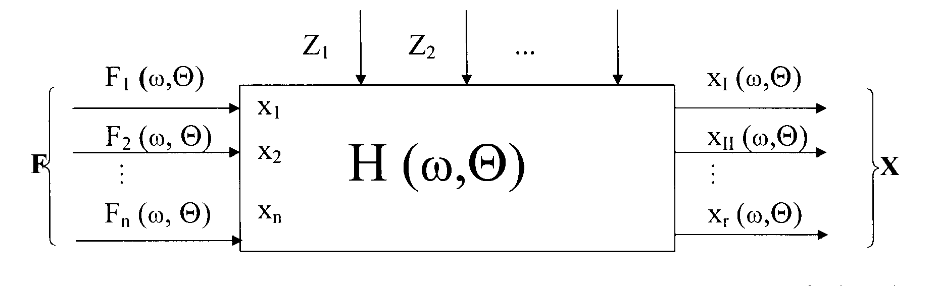
Drawing.19.2 Model of machine as multi-input and multi-output mechanical system, described in frequency domain

Elements V_{i,} F_{k} of the matrix of loads power distribution are scalar products of corresponding elements of transposed vector of input elements $F_{k}^{\text{Tr}}\left(t,Θ\right)$ multiplied left-sided by corresponding elements of vibrations velocity vector V_{i}(t,Θ).
In the frequency domain the matrix of power spectrum distribution is determined y the matrix of dynamic characteristics of the system and the matrix of mutual power spectrum of elements of input function vector.
$V_{i}\left(ω,Θ\right) F_{k}^{\text{Tr}}\left(ω,Θ\right)=H_{V_{\text{ik}}}\left(jω,Θ\right)F_{k}\left(ω,Θ\right)F_{k}^{\text{Tr}}\left(ω,Θ\right)$ (19.14)
where: $H_{V_{\text{ik}}}\left(jω,Θ\right)$ – the matrix of system dynamic mobility,
* – the symbol of matrix feedback
The holistic model of state of machine loads is described by the power spectrum distribution matrix of dynamic loads in the mechanical system:
$\left\{G_{N_{\text{ik}}}\left(jω,Θ\right)\right\}=H_{V_{\text{ik}}}\left(jω,Θ\right)G_{F_{k}F_{k}}\left(jω,Θ\right)$ (19.15)
where:$H_{V_{\text{ik}}}\left(jω,Θ\right)$– the matrix of dynamic mobility,
$G_{F_{k}F_{k}}\left(jω,Θ\right)$ – the matrix of density of spectral input functions
Elements of matrix of dynamic characteristics [19]:
$H_{\text{ik}}\left(jω,D\left(r,Θ\right)\right) =\left\{\begin{matrix}H_{\text{11}}\left[jω,D_{\text{11}}\left(Θ\right)\right] & … & H_{1n}\left[jω,D_{1n}\left(Θ\right)\right] \\ H_{n1}\left[jω,D_{n1}\left(Θ\right)\right] & … & H_{\text{nn}}\left[jω,D_{\text{nn}}\left(Θ\right)\right]\end{matrix}\right\}$ (19.16)
Are functions of the spacial destruction measure of the mechanical system, where:
$D\left(r,Θ\right)≡\frac{E_{d}\left(r,Θ\right)}{E_{b}\left(r\right)}=\frac{\int_{0}^{Θ}{P\left[\left(r,Θ\right),N_{i}\right]dΘ}}{E_{b}\left(r\right)}$ (19.17)
In the discrete model each of elements of the destruction matrix is:: $D_{\text{ik}}\left(Θ\right)=\frac{E_{{\text{ik}}_{d}}\left(Θ\right)}{E_{{\text{ik}}_{\text{db}}}}$, where i,k=1, 2...n are node point of the object
In the multi-input and multi-output mechanical system the matrix of power distribution of machine dynamic loads is:
${\overline{N}}_{\text{ik}}\left(Θ\right)=\left\{\begin{matrix}{\overline{N}}_{{\text{11}}_{\text{dyss}\text{.}}} & {\overline{N}}_{\text{12}} & … & {\overline{N}}_{1n} \\ {\overline{N}}_{\text{21}} & {\overline{N}}_{{\text{22}}_{\text{dyss}\text{.}}} & … & {\overline{N}}_{2n} \\ {\overline{N}}_{r1} & {\overline{N}}_{r2} & … & {\overline{N}}_{\text{rn}\text{dyss}\text{.}}\end{matrix}\right\}$ r > n (19.18)
where k = 1, 2, ... n – points of application of input functions,
i = 1, 2, ..., n, n + 1, n + 2, ... r – research points accepted as critical ones of the constructions in terms of its durability

Example: Determining the power distribution of the double-supported system loads
F₁
F₂
v₁
v₃
v₂
v_{n}

Draw.19.3 The scheme of determining loads of doble-supported driving system

Power distribution of loads in the object:
$N\left(w,Q\right)=\left\{\begin{matrix}N_{\text{11}}\left(w,Q\right) & N_{\text{12}}\left(w,Q\right) \\ N_{\text{21}}\left(w,Q\right) & N_{\text{22}}\left(w,Q\right) \\ N_{\text{31}}\left(w,Q\right) & N_{\text{32}}\left(w,Q\right) \\ N_{n1}\left(w,Q\right) & N_{n2}\left(w,Q\right)\end{matrix}\right\}=\left\{\begin{matrix}H_{\text{11}}\left(w,Q\right) & H_{\text{12}}\left(w,Q\right) \\ H_{\text{21}}\left(w,Q\right) & H_{\text{22}}\left(w,Q\right) \\ H_{\text{31}}\left(w,Q\right) & H_{\text{32}}\left(w,Q\right) \\ H_{n1}\left(w,Q\right) & H_{n2}\left(w,Q\right)\end{matrix}\right\}⋅\left\{\begin{matrix}F_{1}^{2}\left(w,Q\right) & F_{1}F_{2}\left(w,Q\right) \\ F_{2}F_{1}\left(w,Q\right) & F_{2}^{2}\left(w,Q\right)\end{matrix}\right\}$ (19.19)
$N\left(w,Q\right)=H_{\text{ik}}\left(w,Q\right)F_{k}\left(w,Q\right)F_{k}\left(w,Q\right)$, k = 1, 2; i = 1, 2, ..., n (19.20)
The power of load in the point „i” of construction:
$N_{i}\left(w,Q\right)=N_{i1}\left(w,Q\right)+N_{i2}\left(w,Q\right)$ (19.21)

The holistic way of modeling means the description of behaviors of the system in space of physical processes, in which elements of the dynamic loads distribution matrix, being a function of dynamic time “t” or the frequency $ω$ and examined in the function of exploitation time$Θ$, show the destruction of elements of the system. The real part of load distribution is the measure of internal dissipation that causes the destruction. Accumulation results of loads existence occur in the destruction of construction elements. The measure of destruction is the work done in the time interval$\text{ΔΘ}$; $L_{d}=\int_{Θ}{N_{d}dΘ}$. Praca $L_{d}$ jest miarą ewolucji stanu technicznego układu. The course of the diagram N_{d}(Θ) show the trend of destruction in the specified node of construction. The description of mechanical dynamic state can be represented by the spacial characteristic of the increase of loads power${\overline{N}}_{\text{ik}}\left(Θ\right)$. Registering powers of sources of input functions ${\overline{N}}_{k}\left(Θ\right)$ and powers ${\overline{N}}_{\text{ik}}\left(Θ\right)$successively for k = 1,2,...n, in every case for following times of digitizing $Θ_{r}$, results of the research is documented on three-dimensional charts.

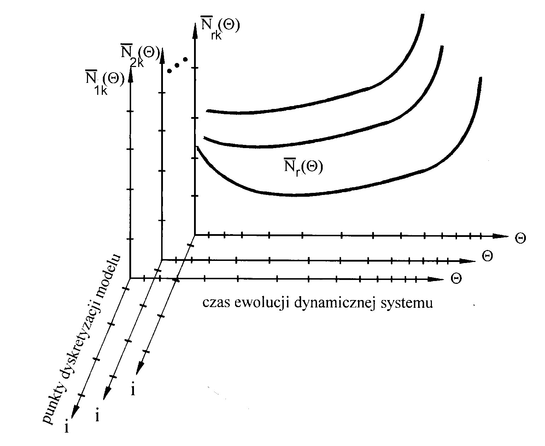
Draw.19.4 Characteristics of load power${\overline{N}}_{\text{ik}}\left(Θ\right)$ [19]

On the drawing there are shown characteristics of changes of average amplitudes of load powers in the dynamic function$Θ$ in the time of evolution. In the energy model the destruction process of the system is reflected by the increase of specific elements of loads power matrix${\overline{N}}_{\text{ik}}\left(Θ\right)$, enabling the localization of the increasing destruction in the object. Spacial character of the load power propagation makes possible representing the model of concentration of dissipated energy in nodal areas of construction.
The characteristic $\frac{\left|ΔN\left(Θ\right)\right|}{N\left(Θ_{0}\right)}$ determined in the time function$Θ$, relates directly to Wöhler’s curve. It describes the characteristic of fatigue process. It enables separable examination of changes of internal dissipation power $\text{Re}N\left(Θ\right)$that causes the destruction and changes of power of dynamic rigidity forces$\text{Im}N\left(Θ\right)$. It gives the possibility of technical state evaluation of the object according to energy criteria.
Analytic forms of machine condition prognostic models can be formed on the basis of determined elements of matrix of power distribution of dynamic loads, examined in the time of machine condition evolution. During the usage of machines in moments Θ_{r} there should not occur overflows of boundary load powers in nodal points of the machine, that is. ${\overline{N}}_{k}\left(Θ_{r}\right)≤{\overline{N}}_{\text{dop}\text{.}}$.
The physical value that stands the basis for determining boundary values for material fatigue destruction is the work of forces of destruction process. There are elements of matrix of energy efforts defined:
${\overline{W}}_{\text{ik}}=\frac{{\overline{N}}_{\text{ik}}}{S_{i}}$ (19.22)
Where: ${\overline{N}}_{\text{ik}}$ are powers of dynamic loads in points “i” produced by applying forces in points „k”,
S_{i} – cross-sectional area of element of machine in the point “i”,
Moreover ${\overline{N}}_{\text{ik}}$ are average powers of load transmitted to point “i” of the machine to points „k” of applying input functions.
Variable loads generate in the material complex processes dependant on the level of input functions and the way of their implementation. When amplitudes of input functions are big enough there may occur elastic-plastic deformations in the material. They are illustrated by the hysteresis loop. The measure of dissipated energy for one volumetric unit of material is the area of hysteresis loop. This area is the function of quantity of plastic deformation during the one stress cycle.
There are elaborated energy models concerning the analysis of durability of steel fatigue life. Enomoto’s hypothesis is based on following assumptions:
– part of energy in one cycle contributes to the destruction in the fatigue process as a consequence of internal friction,
– total proper energy being the cause of fatigue is constant
According to criterion of fatigue strength proposed by F. Ellyin and D. Kujawski, the measure of destruction is the sum of half of dissipated energy and the half of product of stress and deformation. In the consequence of cyclic loading a part of vibration energy is irreversibly dissipated. The sum of deformation of dissipation energy in one cycle is accepted as the parameter of destruction, as the consequence of generating plastic deformations and the elastic energy density in one half-cycle of stretching, causing the creation and evolution of fatigue fracture. In order to estimate the durability of elements of machine it is required to know the dissipated power (real part of efforts ReW_{ik}(Θ) and separating the power of dynamic rigidity ImW_{ik}(Θ)) [22].
$$\int_{Θ_{0}}^{Θ_{r}}{\text{Re} W_{\text{ik}}\left(Θ\right)dΘ}+\frac{1}{2}\int_{Θ_{0}}^{Θ_{r}}{\text{Im} W_{\text{ik}}\left(Θ\right)dΘ}E_{\text{gr}}$$
In order to determine the work of forces of destruction process it is necessary to know the integrand. Instantaneous overloads can also reach boundary values. The quantitiy of dissipated energy and its distribution in the material volume decides about durability of elements.
Diagnostic research of exploitation durability of machines using the method of distribution of power of stresses bases on separated identification of vector of input functions and their dynamic characteristics.
The research of fatigue life of machines encloses the knowledge about:
1) exploitation loads
2) fatigue characteristics of elements,
3) hypotheses of summing failures
Corroding medium decreases fatigue strength. There is distinguished: volumetric fatigue and fitting of surface layer.
A method of superposition of local and global stresses is used: $f\left(Dd\right)$determines the function of probability density of range of stresses$Ds$.
Prognosis process is based on calculations of spectrum density function of stresses:
$$S_{Δσ}\left(ω\right)=H_{Δσ}^{2}\left(ω\right) G\left(ω\right)$$
The residual fatigue life is the function of history of stress spectrum and initial durability. Degradation of object is the condition for accumulating results of wear processes. Te boundary fatigue life is the function of material and the level of stresses. The basic problem is determining the level of residual durability of the whole machine. It is necessary to determine the synergism of factors decreasing the durability of construction: corrosive fatigue factors, influence of the environment (temperature, pressure). The basic one is the synergism of technology of surface engineering in increase of durability
:
– technology of strengthening surface layer, coat,
– heat treatment with electron-beam machining and laser machining (hardening),
– manufacturing technologies of anticorrosive coats.

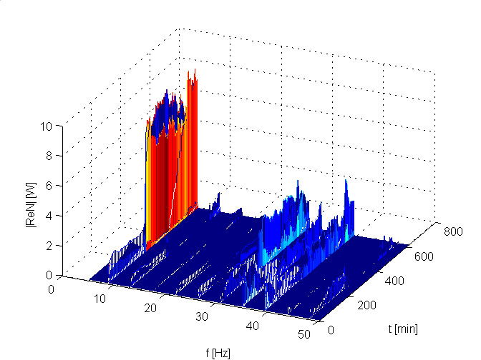
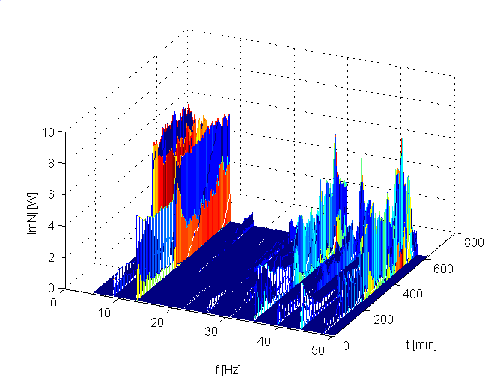
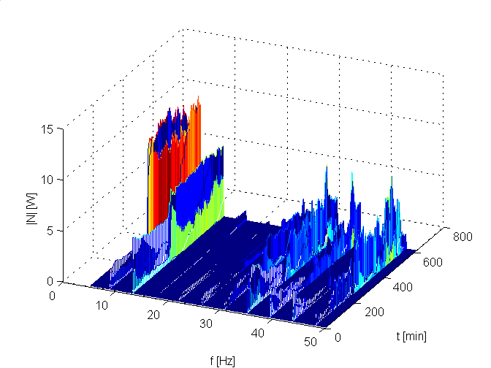

Draw.19.7 Spectrums of stress powers of the spring N(f,Θ) in the band 5Hz – 50Hz

Literature

1. Banek T., Batko W.: Estymacja zaburzeń w systemach monitorujących, Wydawnictwo AGH, Kraków 1997.
2. Cempel C.: Diagnostyka wibroakustyczna maszyn, PWN Warszawa 1989.
3. Cempel C.: Modele diagnostyki wibroakustycznej, Diagnostyka Maszyn Roboczych i Pojazdów, Bydgoszcz, 1994.
4. Cempel C.: Modele systemów przetwarzania energii w teorii i inżynierii systemów. Promocja na Doktora Honoris Causa Politechniki Szczecińskiej, Politechnika Szczecińska, 1995.
5. Cempel C., Tabaszewski M.: Teoria degradacji maszyn i urządzeń jako ewolucyjnych systemów otwartych z ograniczoną dyssypacją - sprawozdanie z badań KBN 0858/P4/93. Politechnika Poznańska IMS 1996.
6. Cempel C.: Teoria inżynierii systemów, skrypt, Zakład Dynamiki - Wibroakustyki Systemów, Politechnika Poznańska 2000.
7. Cholewa W., Kiciński J.: Diagnostyka techniczna, Odwrotne modele diagnostyczne, Wydawnictwo Politechniki Śląskiej, Gliwice 1997.
8. Czajgucki J. Z.: Jedność i integracja nauki o niezawodności obiektów technicznych, antropotechnicznych i socjotechnicznych, Zagadnienia Eksploatacji Maszyn, Zeszyt 2 (126), vol.36 Instytut Technologii Eksploatacji, Radom 2001.
9. Dąbrowski Z.: Rezonans nieliniowy jako symptom diagnostyczny, XXV Ogólnopolskie Sympozjum Diagnostyka Maszyn, Węgierska Górka 1998.
10. Engel Z.: Ochrona środowiska przed drganiami i hałasem, PWN, Warszawa 1993.
11. Giergiel J., Uhl T.: Identyfikacja układów mechanicznych, PWN, Warszawa, 1990.
12. Kaźmierczak H.: Szacowanie przestrzennego rozkładu mocy obciążeń dynamicznych w systemie mechanicznym, Materiały Międzynarodowej Konferencji-Diagnostyka Maszyn Roboczych i Pojazdów, Bydgoszcz, 1999.
13. Kaźmierczak H.: Analysis of the external load power distribution for vibration reduction, International Congress on Sound Vibration, Garmisch- Partenkirchen, 2000.
14. Kaźmierczak H.: Holistyczny model rozpływu mocy obciążeń dynamicznych w systemach mechanicznych, II Międzynarodowy Kongres Diagnostyki Technicznej, Diagnostyka 2000, Warszawa.
15. Kaźmierczak H.: Kryteria oceny własności dynamicznych maszyny, PIMR 6595, Poznań 1988.
16. Kaźmierczak H., Kromulski J.: Analiza diagnostyczna maszyny poddanej obciążeniom niestacjonarnym z pomocą transformaty WEVELET, XXV Ogólnopolskie Sympozjum Diagnostyki Maszyn, Węgierska Górka 1998.
17. Kaźmierczak H.: Model rozpływu energii w systemach mechanicznych, Diagnostyka, vol.23. 2000. 1000 Otwarte Seminarium Zakładu Dynamiki i Wibroakustyki Systemów Politechniki Poznańskiej, Poznań 2000.
18. Kaźmierczak H.: Dynamic load power distribution in mechanical systems, Zagadnienia Eksploatacji Maszyn Z. 3(127) vol. 36, 2001.
19. Kaźmierczak H.: Analiza rozkładu mocy obciążeń dynamicznych w systemach mechanicznych. Poznań 2001, Rozprawy 363.
20. Kaźmierczak H.: Badania trwałości zmęczeniowej maszyn metodą analizy rozkładu mocy obciążeń dynamicznych, Diagnostyka, vol. 26, 2002.
21. Kiciński J.: Analiza komputerowa w diagnostyce technicznej maszyn, Kongres Diagnostyki Technicznej KTD’ 96, Gdańsk s.93-122.
22. Osiński Z.: Tłumienie drgań, PWN, Warszawa 1997.
23. Osiński Z., Radkowski S.: Rozpoznawanie uszkodzeń jako element niezawodnościowo - zorientowanej obsługi maszyny, XXVII Ogólnopolskie Sympozjum Diagnostyka Maszyn, Węgierska Górka 2000.
24. Orłowski Z.: Diagnostyka w życiu turbin parowych, WNT, Warszawa 2001.
25. Radkowski S.: Wibroakustyczna diagnostyka uszkodzeń niskoenergetycznych, Wydawnictwo Instytutu Technologii Eksploatacji, Warszawa – Radom 2002.
26. Tabaszewski M., Cempel C.: Próba uwzględnienia niestacjonarności i nieliniowości w procesorze energii jako modelu ewolucji stanu maszyny, XXIII Ogólnopolskie Sympozjum Diagnostyka Maszyn Węgierska Górka 1996 s.64-72.
27. Uhl T., Lisowski W.: Praktyczne problemy analizy modalnej konstrukcji, AGH Kraków 1996.
28. Uhl T.: Komputerowo wspomagana identyfikacja modeli konstrukcji mechanicznych,
WNT, Warszawa 1997.
29. Uhl T., Lisowski W.: Eksploatacyjna analiza modalna i jej zastosowanie, Akademia Górniczo-Hutnicza, Kraków 1999.
30. Żółtowski B.: Podstawy diagnostyki maszyn, ATR Bydgoszcz, 1996.
31. Żółtowski B., Niziński S.: Modelowanie procesów eksploatacji maszyn, Wydawnictwo MARKAR-BZ, Bydgoszcz - Sulejówek, 2002.

